

This is a post about feature selection using genetic algorithms in R, in which we will do a quick review about:

* What are genetic algorithms?
* GA in ML?
* What does a solution look like?
* GA process and its operators
* The fitness function
* Genetics Algorithms in R!
* Try it yourself
* Relating concepts

*Animation source: "Flexible Muscle-Based Locomotion for Bipedal Creatures" – Thomas Geijtenbeek*

**The intuition behind**

Imagine a black box which can help us to decide over an **unlimited number of possibilities**, with a criterion such that we can find an acceptable solution (both in time and quality) to a problem that we formulate.

**What are genetic algorithms?**

Genetic Algortithms (GA) are a mathematical model inspired by the famous Charles Darwin’s idea of *natural selection*.

The natural selection preserves only the fittest individuals, over the different generations.

Imagine a population of 100 rabbits in 1900, if we look the population today, we are going to others rabbits more fast and skillful to find food than their ancestors.

**GA in ML**

In **machine learning**, one of the uses of genetic algorithms is to pick up the right number of variables in order to create a predictive model.

To pick up the right subset of variables is a problem of **combinatory and optimization**.

The advantage of this technique over others is, it allows the best solution to emerge from the best of prior solutions. An evolutionary algorithm which improves the selection over time.

The idea of GA is to combine the different solutions **generation after generation** to extract the best *genes* (variables) from each one. That way it creates new and more fitted individuals.

We can find other uses of GA such as hyper-tunning parameter, find the maximum (or min) of a function or the search for a correct neural network arquitecture (Neuroevolution), or among others…

**GA in feature selection**

Every possible solution of the GA, which are the selected variables (a *single* ), are **considered as a whole**, it will not rank variables individually against the target.

**What does a solution look like?**

Keeping it simple for the example, imagine we have a total of 6 variables,

One solution can be picking up 3 variables, let’s say: var2, var4 and var5.

Another solution can be: var1 and var5.

These solutions are the so-called **individuals** or **chromosomes** in a population. They are possible solutions to our problem.

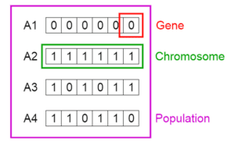

*Credit image: Vijini Mallawaarachchi*

From the image, the solution 3 can be expressed as a one-hot vector: c(1,0,1,0,1,1). Each 1 indicates the solution containg that variable. In this case: var1, var3, var5, var6.

While the solution 4 is: c(1,1,0,1,1,0).

Each position in the vector is a **gene**.

**GA process and its operators**

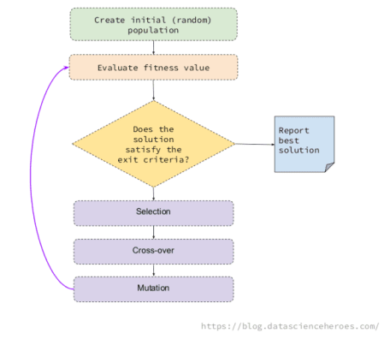

The underlying idea of a GA is to generate some random possible solutions (called population), which represent different variables, to then combine the best solutions in an iterative process.

This combination follows the basic GA operations, which are: selection, mutation and cross-over.

* **Selection**: Pick up the most fitted individuals in a generation (i.e.: the solutions providing the highest ROC).
* **Cross-over**: Create 2 new individuals, based on the genes of two solutions. These children will appear to the next generation.
* **Mutation**: Change a gene randomly in the individual (i.e.: flip a 0 to 1)

The idea is for each generation, we will find better individuals, like a fast rabbit.

These basic operations allow the algorithm to change the possible solutions by combining them in a way that maximizes the objective.

**The fitness function**

This objective maximization is, for example, to keep with the solution that maximizes the area under the ROC curve. This is defined in the *fitness function*.

The fitness function takes a possible solution (or chromosome, if you want to sound more sophisticated), and *somehow* evaluates the effectiveness of the selection.

Normally, the fitness function takes the one-hot vector c(1,1,0,0,0,0), creates, for example, a random forest model with var1 and var2, and returns the fitness value (ROC).

The fitness value in this code calculates is: ROC value / number of variables. By doing this the algorithm penalizes the solutions with a large number of variables.

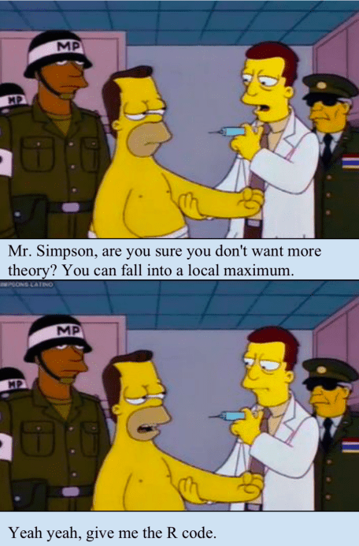

**Genetics Algorithms in R! **

My intention is to provide you with a clean code so you can understand what’s behind, while at the same time, try new approaches like modifying the fitness function. This is a crucial point.

To use on your own data set, make sure data_x (data frame) and data_y (factor) are compatible with the custom_fitness function.

The main library is GA.



# data_x: input data frame

# data_y: target variable (factor)

# GA parameters

param_nBits=ncol(data_x)

col_names=colnames(data_x)

# Executing the GA

ga_GA_1 = ga(fitness = function(vars) custom_fitness(vars = vars,

data_x = data_x,

data_y = data_y,

p_sampling = 0.7), # custom fitness function

type = "binary", # optimization data type

crossover=gabin_uCrossover, # cross-over method

elitism = 0.1, # elitism prob

pmutation = 0.03, # mutation rate prob

popSize = 50, # the number of indivduals/solutions

nBits = param_nBits, # total number of variables

names=col_names, # variable name

run=5, # max iter without improvement (stopping criteria)

maxiter = 50, # total runs or generations

monitor=plot, # plot the result at each iteration

keepBest = TRUE, # keep the best solution at the end

parallel = T, # allow parallel procesing

seed=84211 # for reproducibility purposes

)

# Checking the results

summary(ga_GA_1)

── Genetic Algorithm ───────────────────

GA settings:

Type = binary

Population size = 50

Number of generations = 50

Elitism = 0.1

Crossover probability = 0.8

Mutation probability = 0.03

GA results:

Iterations = 15

Fitness function value = 0.1648982

Solution =

radius_mean texture_mean perimeter_mean area_mean smoothness_mean compactness_mean

[1,] 0 0 0 0 0 1

concavity_mean concave points_mean symmetry_mean fractal_dimension_mean ...

[1,] 0 1 0 0

symmetry_worst fractal_dimension_worst

[1,] 0 0

# Following line will return the variable names of the final and best solution

best_vars_ga=col_names[ga_GA_1@solution[1,]==1]

# Checking the variables of the best solution...

best_vars_ga

[1] "compactness_mean" "concave points_mean" "symmetry_se" "radius_worst"

[5] "compactness_worst" "concavity_worst"



* Blue dot: Population fitness average
* Green dot: Best fitness value

Note: Don’t expect the result that fast 

Now we calculate the accuracy based on the best selection!

get_accuracy_metric(data_tr_sample = data_x, target = data_y, best_vars_ga)

[1] 0.9402818

The accuracy is around 94%, while the ROC value is closed to 0,95 (ROC=fitness value * number of variables, check the fitness function).

**Analyzing the results**

I don’t like to analyze the accuracy without the cutpoint, but it’s useful to compare with the results of this .He got a similar accuracy result using recursive feature elimination, or RFE.

**Try it yourself**

Try a new fitness function, some solutions still provide a large number of variables, you can try squaring the number of variables.

Another thing to try is the algorithm to get the ROC value, or even to change the metric.

Some configurations last a lot of time. Balance classes before modeling and play with the p_sampling parameter. Sampling techniques can have a big impact on models.

How about changing the rate of mutation or elitism? Or trying other cross-over methods?

Increase the popSize to test more possible solutions at the same time (at a time cost).

Feel free to share any insights or ideas to improve the selection.

**Relating concepts**

There is a parallelism between GA and Deep Learning, the concept of iteration and improvement over time is similar.

I added the p_sampling parameter to speed up things. And it usually accomplishes its goal. Similar to the *batch* concept used in Deep Learning. Another parallel is between the GA parameter run and the *early stopping* criteria in the neural network training.

But the biggest similarity is both techniques come from **observing the nature**. In both cases, humans observed how neural networks and genetics work, and create a simplified mathematical model that imitate their behavior. Nature has millions of years of evolution, why not try to imitate it? 

—

I tried to be brief about GA, but if you have any specific question on this vast topic, please leave it in the comments ‍

*And, if I didn’t motivate you the enough to study GA, check this project which is based on Neuroevolution:*